Steel casting design
Steel casting machining
Steel casting finish
Steel casting OEM
Carbon steel casting
Stainless steel casting
Alloy steel casting
Water glass steel casting
Silica sol steel casting
Investment casting
Precision casting
Lost wax steel casting
Heat treatment
Surface finishing
Electroplating
Steel cast coupling
Steel cast kitchen part
Steel cast valve
Steel cast marine hardware
Steel building hardware
Steel machinery parts
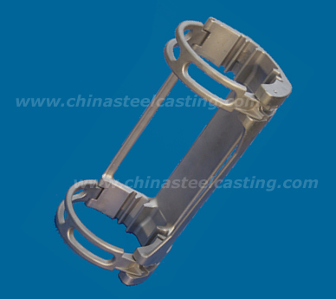

The Detail of alloy steel precision cast clamp, clamp of alloy steel investment casting:
Model No: alloy steel precision cast clamp -03
Casting series: alloy steel investment casting
Casting Material: alloy steel
Casting type: silica sol precision casting
Lead time of die casting mold: 25 days
Post treatment: acid cleaning
Precision Machining: drilling and milling by machining center
Product Origin: China
Brand Name: Cinda steel investment casting
Price Terms: FOB Ningbo
Payment Terms: T/T,L/C
Supply Ability: 30,000-40,000sets/month
Die casting mold lead time: around 30 days
If you want to purchase or know more information about alloy steel investment cast clamp – 03, please contact us!
sales@chinasteelcasting.com

